RICHARD JAMESON

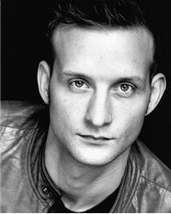

E-mail: richardjameson@live.co.uk

Personal details

Height- 5’9”
Build- Medium
Eyes- Blue/grey
Hair- Light brown, short.
D.O.B- 06/12/1980

QUALIFICATIONS

B-TEC in performing arts (1999)
B.A hons acting (2005)

CREDITS

2008 T.I.E Aladdin ALADDIN, Pyramid Productions.
2008 T.I.E Paul DRIVER SAFETY, Cragrats.
2008 Stage Young Talbot HENRY VI, Gemma Colclough.
2008 Corporate Gaz EQUALITY AND DIVERSITY, Cragrats
2008 Stage Cain & Abel WAITRESS FOR GODOT, Ian Craddock.
2007 Short Film. Alex, TEA FOR TWO, Lee Barber.
2007 Short Film. Armed Robber, DASH, Mike Ellis.
2007 Voice Work. Amber Valley security and safety systems
2007 Stage, Chorus/, HENRY V, Pippo Del Bono (RSC)
Earl of Cambridge
2006 Feature film, Police Officer, FRAMED (w.t), John Kirby
2005 Short Film, Police Inspector, Mr.Fingers, John Humphreys
2005 Stage, Arthur Kipps, Half a Sixpence, Amanda Knott
2005 Stage, Stephano, The Rover, Bob Eaton
2004 Stage, Leonardo, Blood Wedding, Sabina Netherclift

SKILLS

Accents: General London, RP, General American, General northern.

Sports: Rock climbing, Ice skating, general exercise and Gym.

